UDM Assignment

## Feed the data given from github party.md into ofbiz

1. Using XML

*<PartyRole partyId="CUST123" roleTypeId="CUSTOMER"></PartyRole>*

*<ContactMech contactMechId="PHONE001" contactMechTypeId="TELECOM_NUMBER" infoString="555-1234"></ContactMech>*

*<ContactMech contactMechId="ADDR001" contactMechTypeId="POSTAL_ADDRESS" infoString="123 Elm Street, Springfield, 12345, USA"></ContactMech>*

*<PostalAddress contactMechId="ADDR001" address1="123 Elm Street" city="Springfield" postalCode="12345" countryGeoId="USA"></PostalAddress>*

*<PartyContactMechPurpose contactMechId="ADDR001" contactMechPurposeTypeId="BILLING_LOCATION" fromDate= "2024-05-27 00:00:00"></PartyContactMechPurpose>*

*<PartyContactMechPurpose contactMechId="PHONE001" contactMechPurposeTypeId="SHIPPING_LOCATION" fromDate= "2024-05-27 00:00:00"></PartyContactMechPurpose>*

*<PartyContactMech partyId = "CUST123" contactMechId = "PHONE001" fromDate = "2024-05-27 00:00:00" ></PartyContactMech>*

*<PartyContactMech partyId = "CUST123" contactMechId = "ADDR001" fromDate = "2024-05-27 00:00:00" ></PartyContactMech>*

**

*<Party partyId="SUPP456" partyTypeId="PARTY_GROUP"></Party>*

*<PartyGroup partyId="SUPP456" groupName="XYZ Supplies Inc."></PartyGroup>*

*<PartyRole partyId="SUPP456" roleTypeId="SUPPLIER"></PartyRole>*

*<ContactMech contactMechId="PHONE002" contactMechTypeId="TELECOM_NUMBER" infoString="555-6789"></ContactMech>*

*<ContactMech contactMechId="ADDR002" contactMechTypeId="POSTAL_ADDRESS" infoString="456 Oak Avenue, Metropolis, 54321, USA"></ContactMech>*

*<PartyContactMech partyId = "SUPP456" contactMechId = "PHONE002" fromDate = "2024-05-27 00:00:00" ></PartyContactMech>*

*<PartyContactMech partyId = "SUPP456" contactMechId = "ADDR002" fromDate = "2024-05-27 00:00:00" ></PartyContactMech>*

*<PostalAddress contactMechId="ADDR002" address1="456 Oak Avenue" city="Metropolis" postalCode="54321" countryGeoId="USA"></PostalAddress>*

*<PartyContactMechPurpose partyId = "SUPP456" contactMechId="ADDR002" contactMechPurposeTypeId="BILLING_LOCATION" fromDate = "2024-05-27 00:00:00"></PartyContactMechPurpose>*

*<PartyContactMechPurpose partyId = "SUPP456" contactMechId="ADDR002" contactMechPurposeTypeId="SHIPPING_LOCATION" fromDate = "2024-05-27 00:00:00"></PartyContactMechPurpose>*

**

1. Using Entity engine

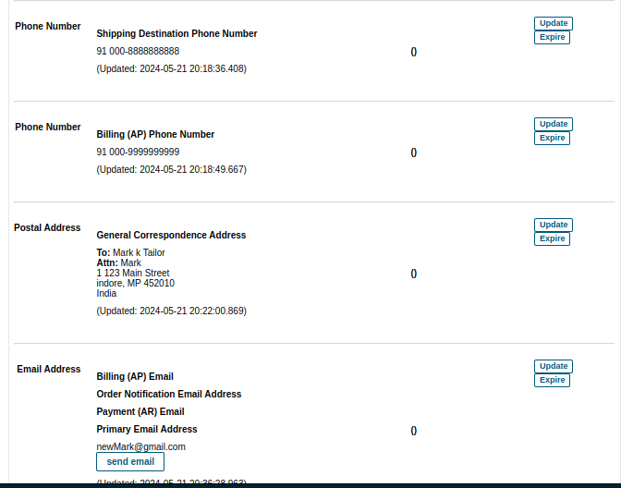

1. Using webtools

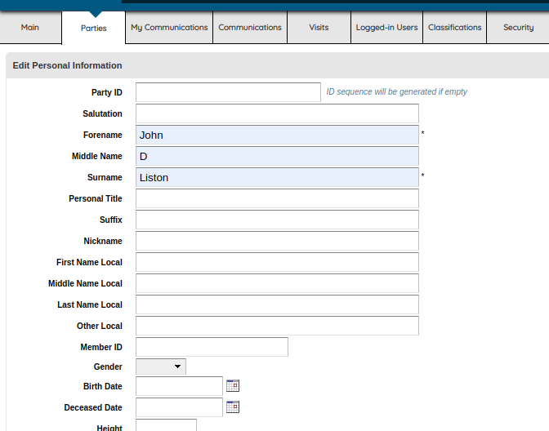

## Backtracking round Gizmo product

**select**

**p.PRODUCT_ID ,**

**p.INTERNAL_NAME,**

**pcm.PRODUCT_CATEGORY_ID ,**

**pc.PRODUCT_CATEGORY_TYPE_ID ,**

**pcc.PROD_CATALOG_ID,**

**pcc.PROD_CATALOG_CATEGORY_TYPE_ID,**

**PS.PRODUCT_STORE_ID ,**

**ps.STORE_NAME**

**from**

**product p**

**join product_category_member pcm on**

**p.PRODUCT_ID = pcm.PRODUCT_ID**

**join product_category pc on**

**pcm.PRODUCT_CATEGORY_ID = pc.PRODUCT_CATEGORY_ID**

**join prod_catalog_category pcc on**

**pc.PRODUCT_CATEGORY_ID = pcc.PRODUCT_CATEGORY_ID**

**join prod_catalog pc2 on**

**pc2.PROD_CATALOG_ID = pcc.PROD_CATALOG_ID**

**join product_store_catalog psc on**

**psc.PROD_CATALOG_ID = pcc.PROD_CATALOG_ID**

**join product_store ps on**

**psc.PRODUCT_STORE_ID = ps.PRODUCT_STORE_ID**

**where**

**p.PRODUCT_ID = "GZ-2644";**

## 

## Creating Products on OfBizzz

Link - > <https://ofbiztraining.hotwaxsystems.com/catalog/control/EditProduct>

Create product 1

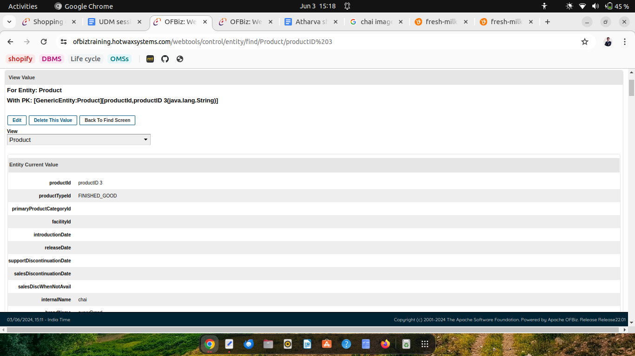

Give price to product 1

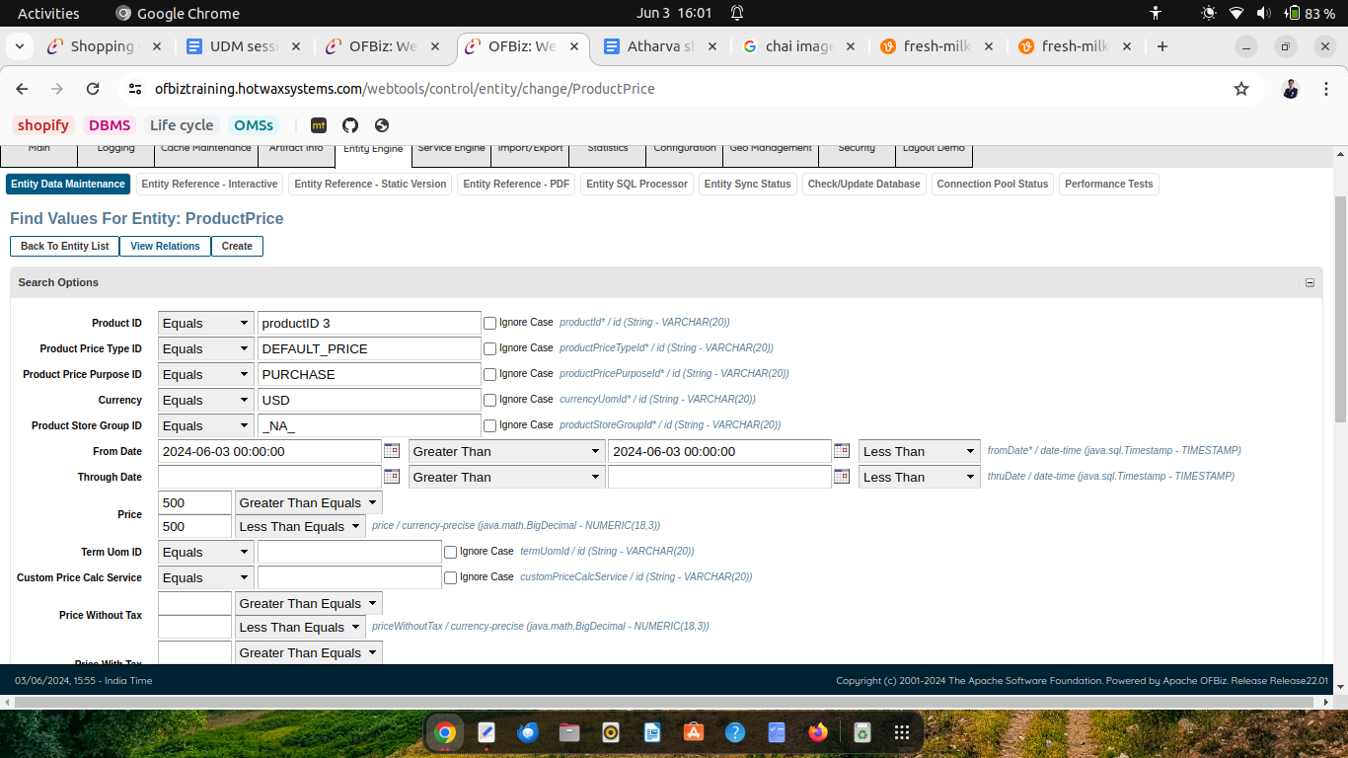

Setting Price of product 2

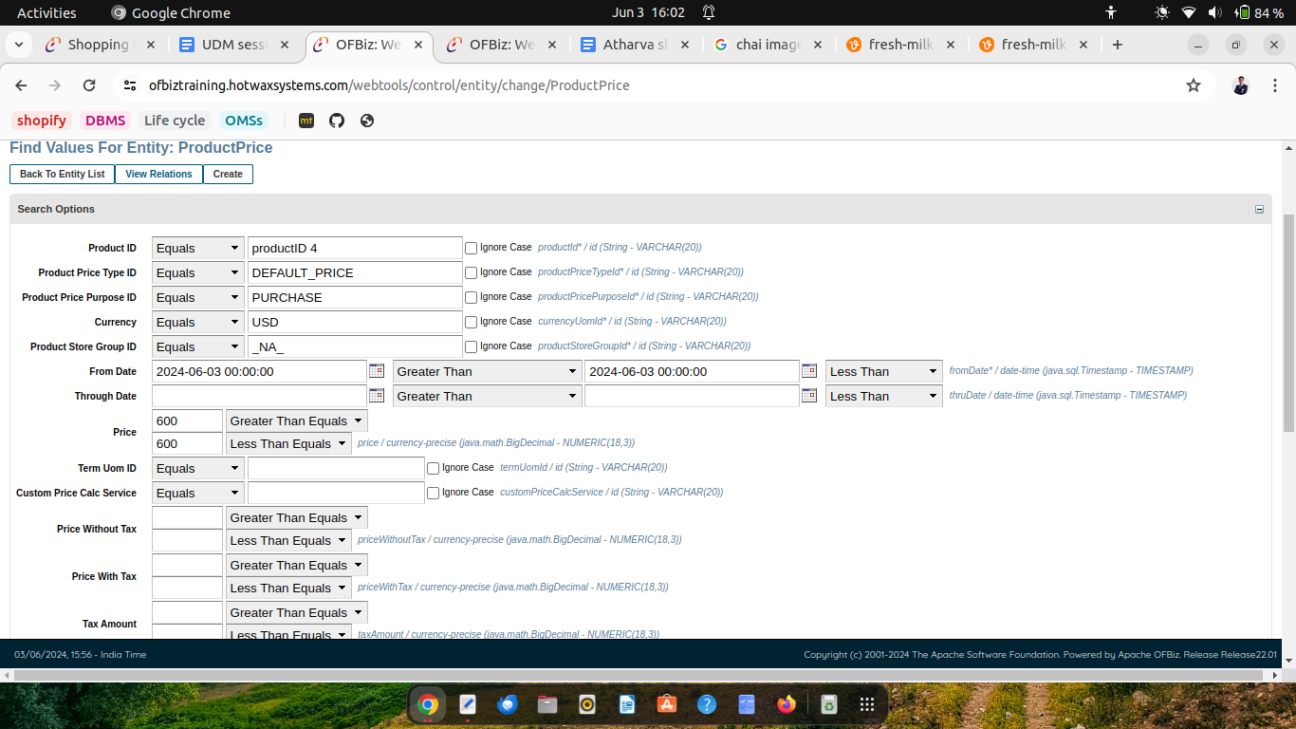

Create product 2

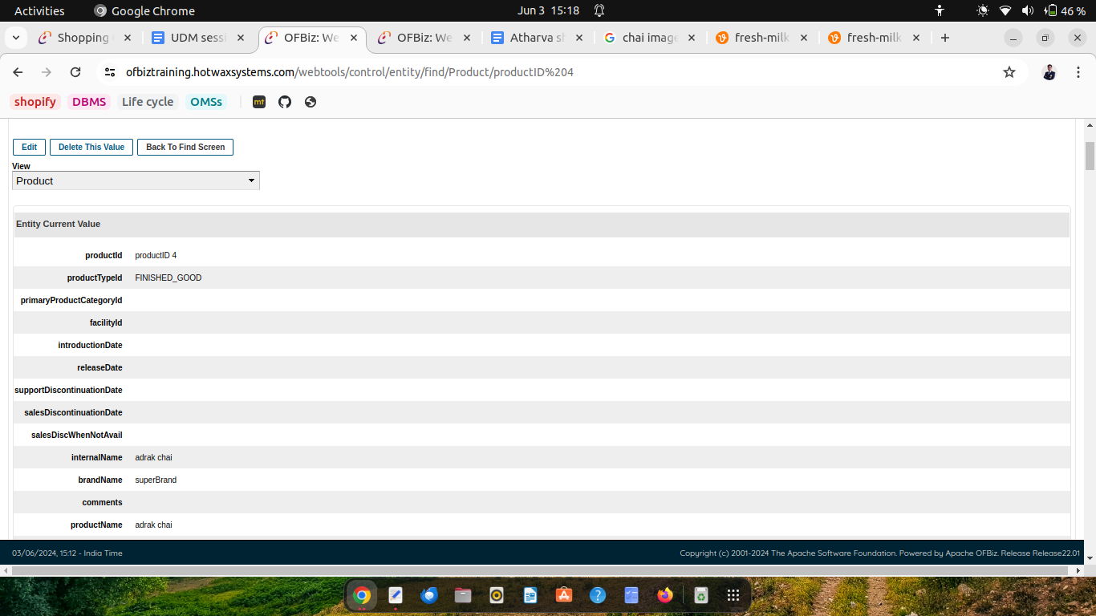

Creating new product 3

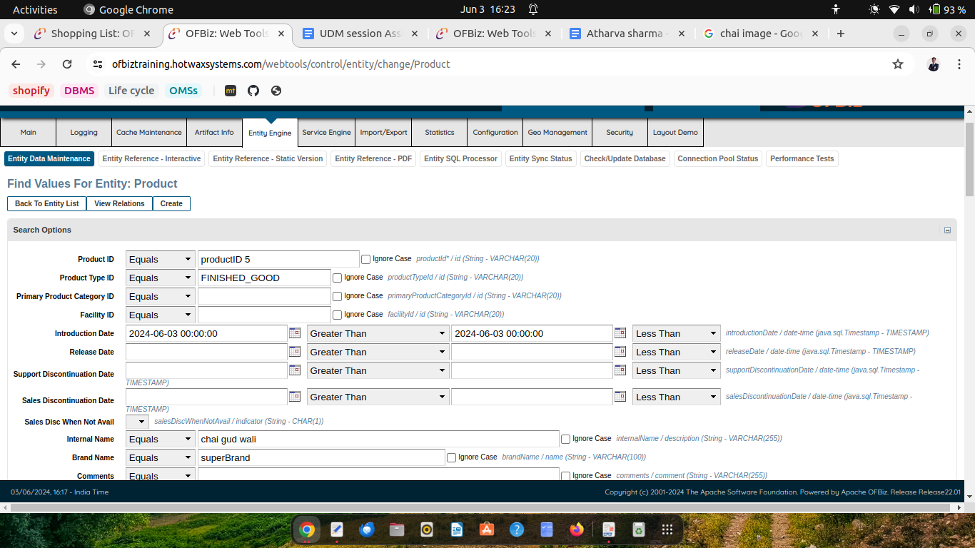

Joint two product using ProductAssoc

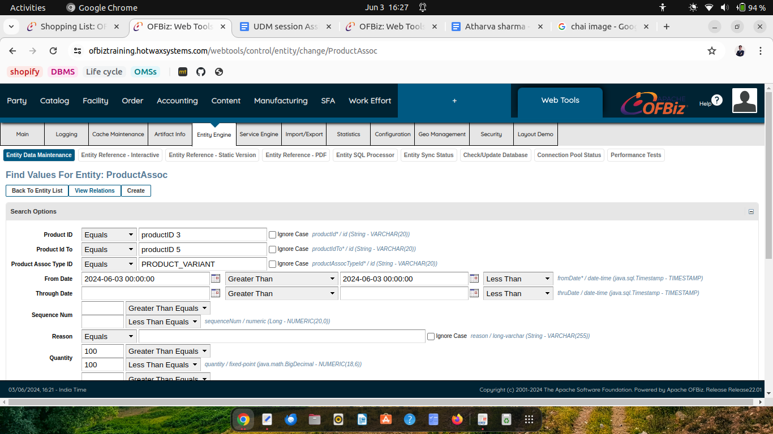

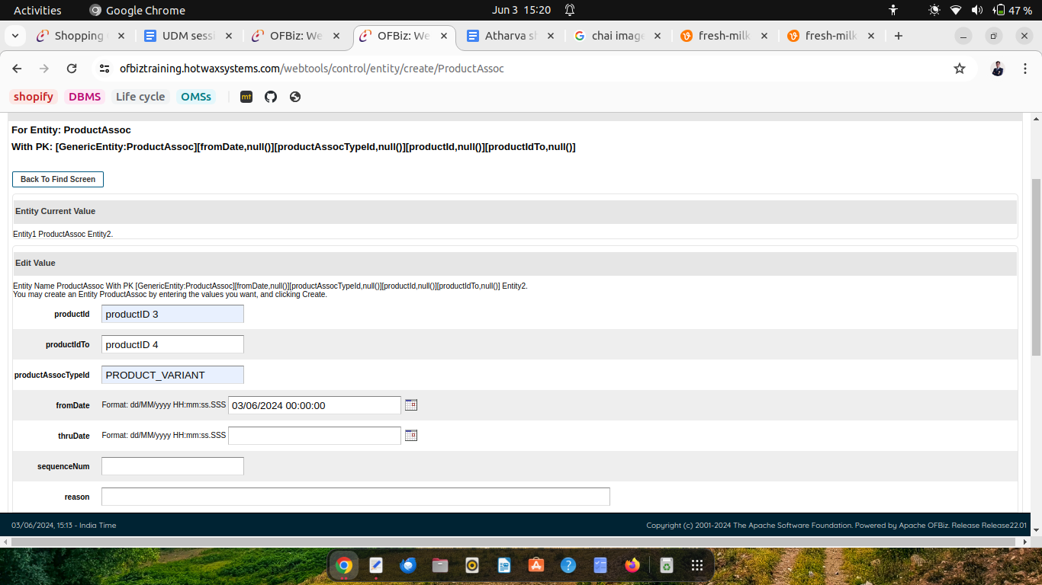

Create product category

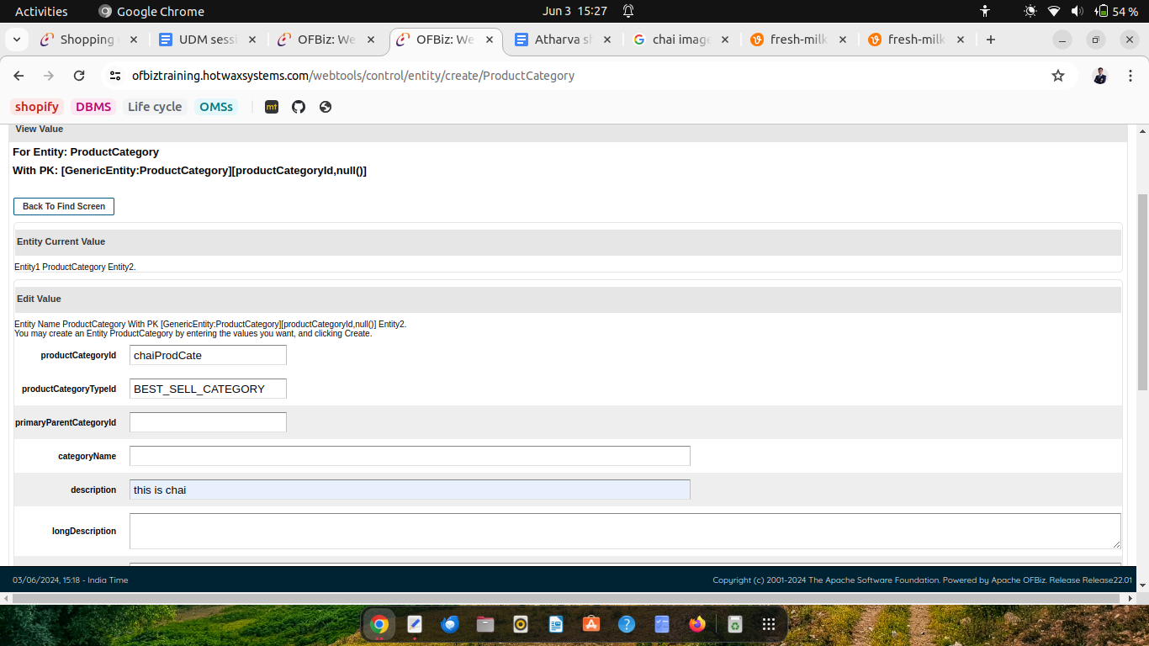

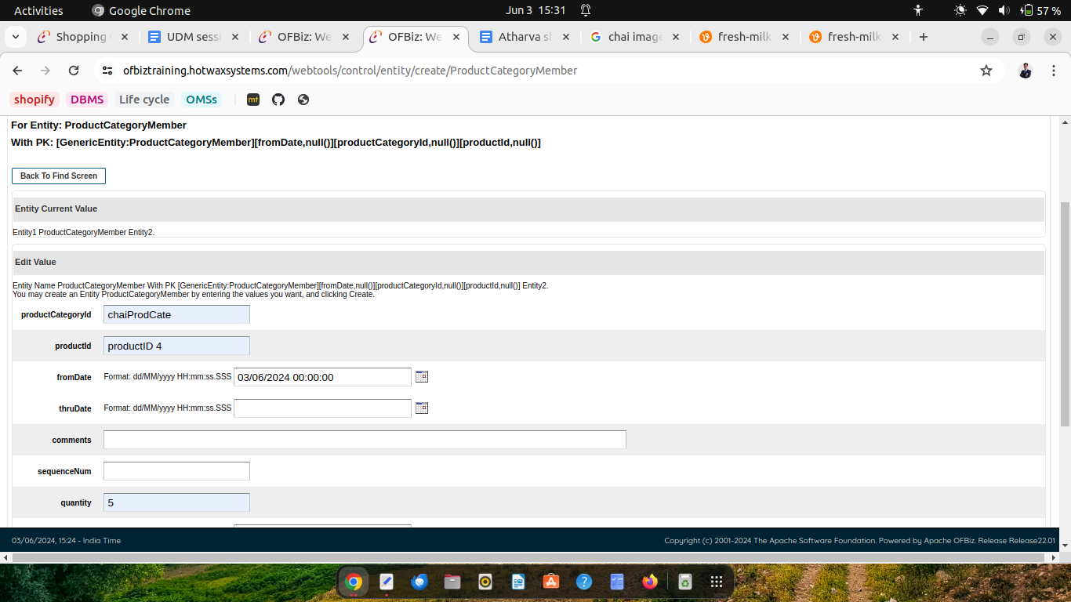

Create Catalog

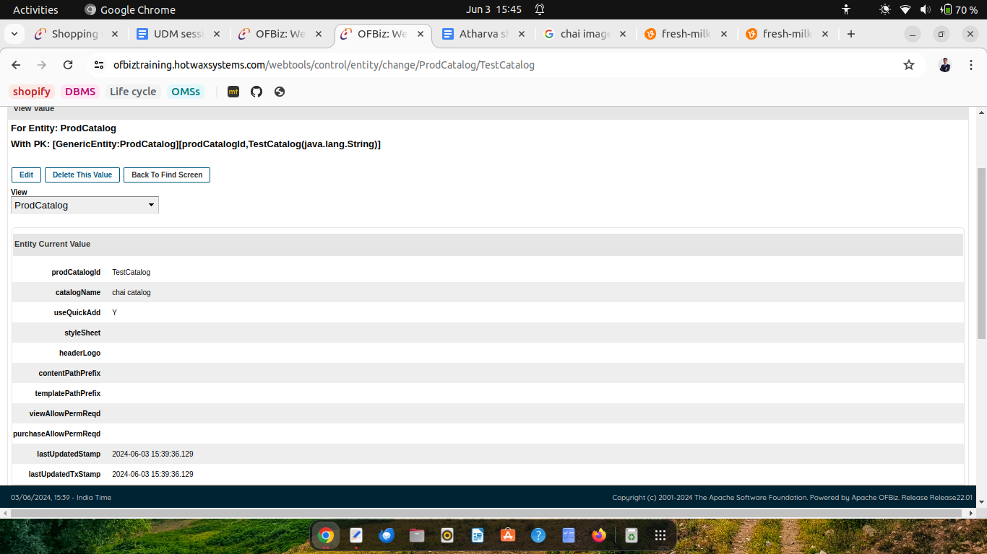

Join category and catalog using ProdcatalogCategory

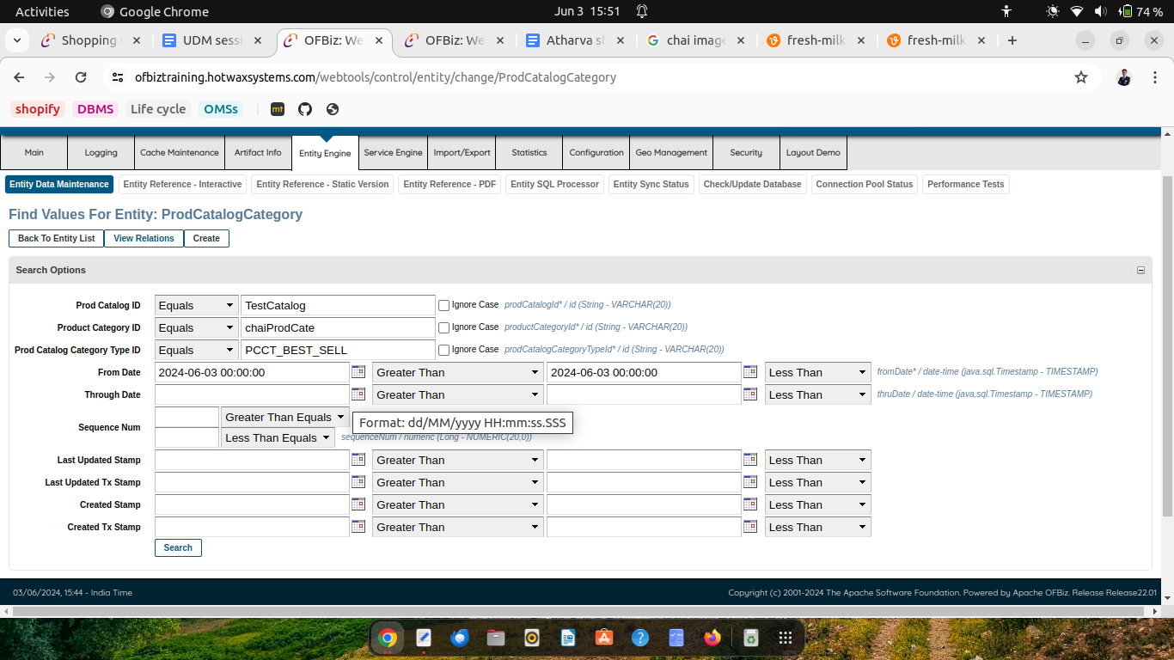

Create product store

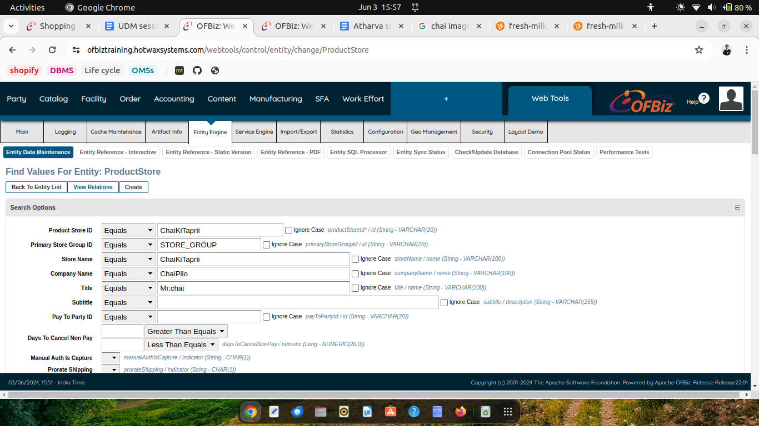

Join Product store to product catalog using ProductStoreCatalog

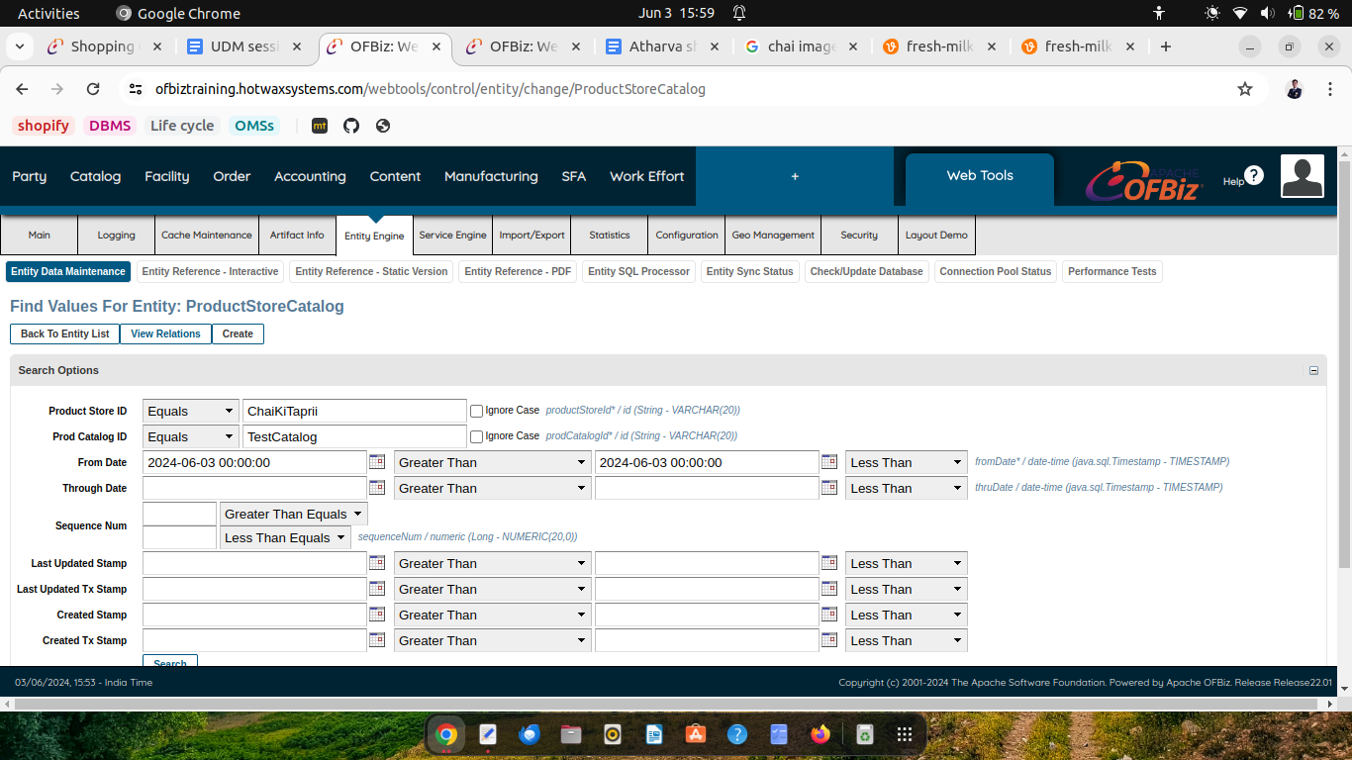

Product can be seen in store

